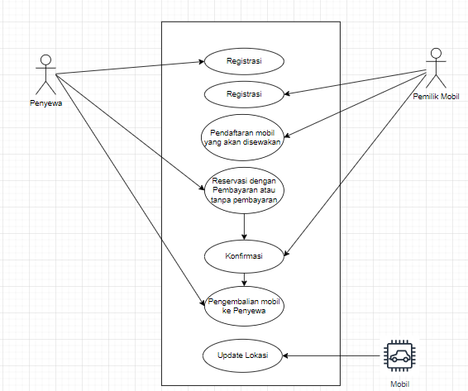Use Case Diagram Mosewa.id